API Security Testing using
Postman

- Executive Summary
This report presents the results of an API security assessment conducted on the OWASP Juice Shop application running in a Dockerized local environment. The testing was performed using Postman to evaluate the security posture of exposed REST APIs.
The objective of this assessment was to identify vulnerabilities aligned with the OWASP API Top 10. During testing, multiple security flaws were discovered, including authentication bypass, broken authorization, and improper input validation.
These vulnerabilities could allow attackers to gain unauthorized access, manipulate data, and potentially compromise sensitive information.

- Scope of Testing
Target Application: OWASP Juice Shop
Environment: Localhost (Docker Container)
Base URL: http://localhost:3000
Testing Tool: Postman
Testing Type: Black-box API Security Testing

- Methodology
The following methodology was used during the assessment:
- Application Interaction: Explored application features (login, search, basket)
- API Discovery: Captured API endpoints using browser developer tools (Network tab)
- Request Replication: Imported endpoints into Postman
- Authentication Testing: Tested login functionality and token generation
- Authorization Testing: Manipulated API parameters to test access control
- Input Validation Testing: Sent malformed and unexpected inputs
- Documentation: Recorded findings with evidence and impact analysis

- Application Overview
OWASP Juice Shop is a deliberately vulnerable web application used for security training. It provides multiple functionalities such as product browsing, user authentication, and shopping cart management.
The application exposes several REST APIs, including:
- /rest/user/login
- /rest/products/search
- /rest/basket/{id}
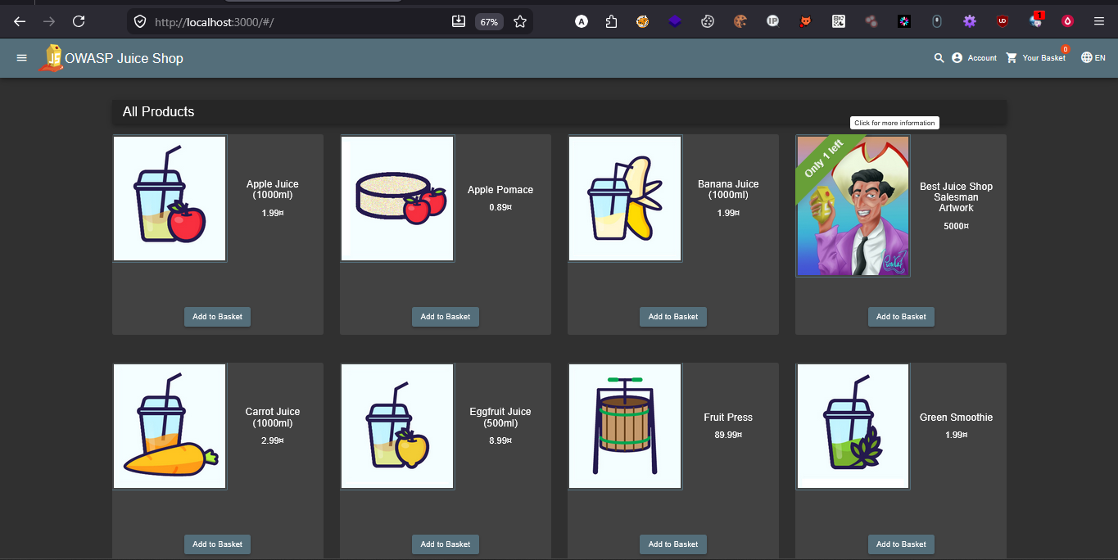
POC 1: Application Homepage

- API Enumeration & Discovery
API endpoints were identified using the browser’s developer tools (Network tab). By interacting with the application (login, search, add to basket), relevant API calls were captured.
Example:
- POST /rest/user/login → Used for authentication
- GET /rest/products/search?q=apple → Used for product search
- GET /rest/basket/{id} → Retrieves basket data
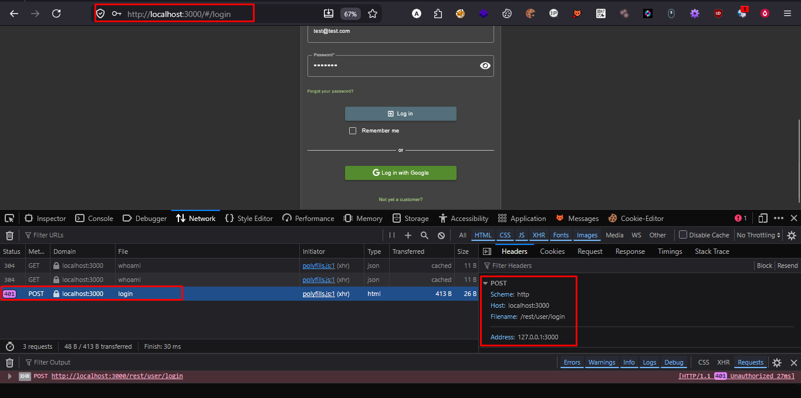
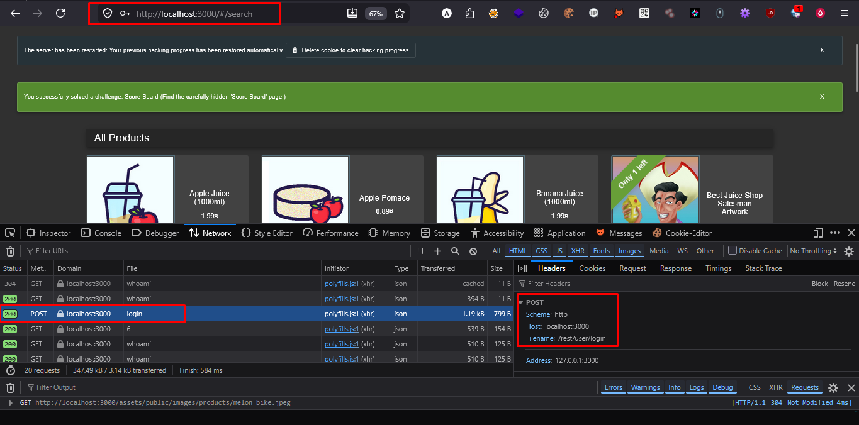
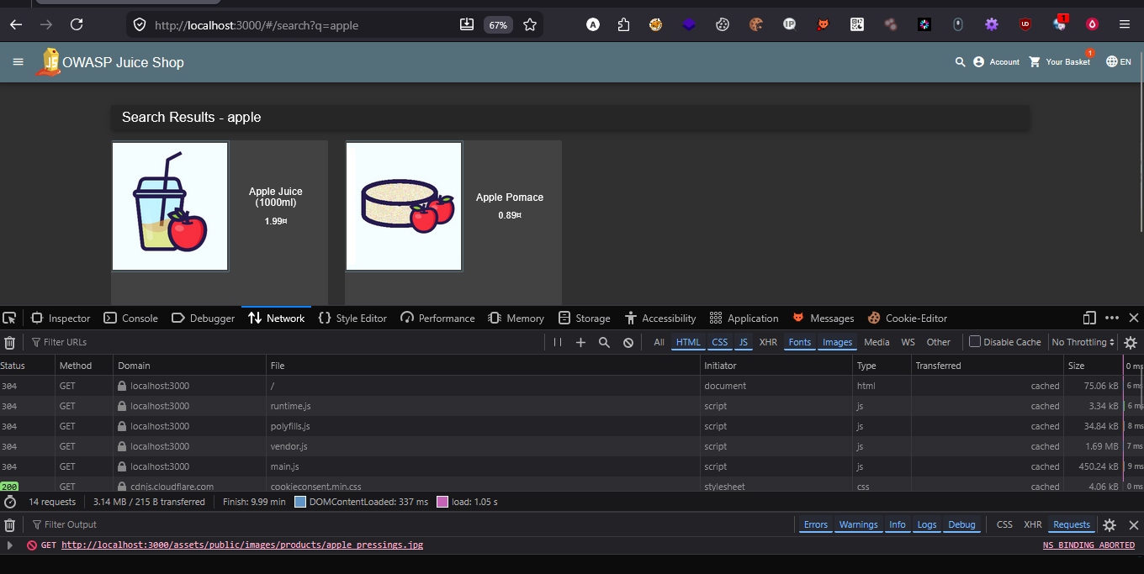
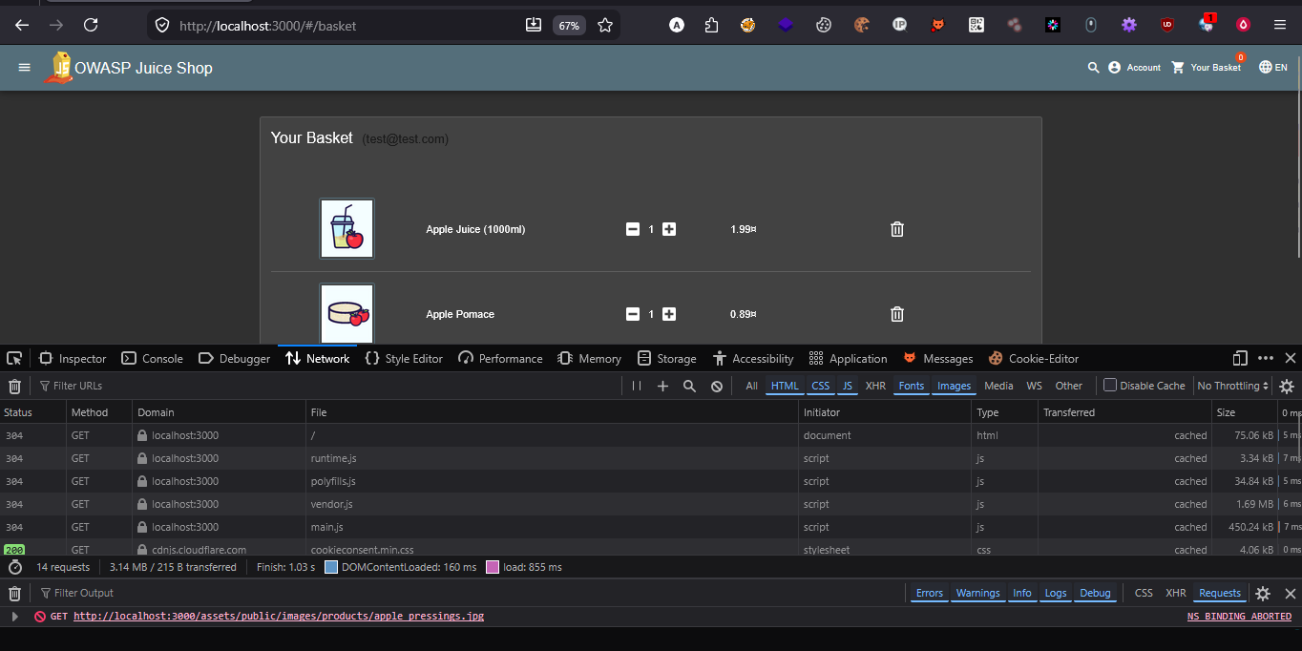
POC 1: Network Tab showing API requests

- Vulnerability Assessment

1.Broken Authentication (SQL Injection)
Endpoint: /rest/user/login
Method: POST
Payload Used:
{
"email": "' OR 1=1 --",
"password": "test"
}
Description:
The login API is vulnerable to SQL Injection. By injecting a malicious SQL payload in the email field, authentication can be bypassed without valid credentials.
Impact:
Unauthorized access to user accounts
Compromise of authentication mechanism
Severity: 🔴 Critical

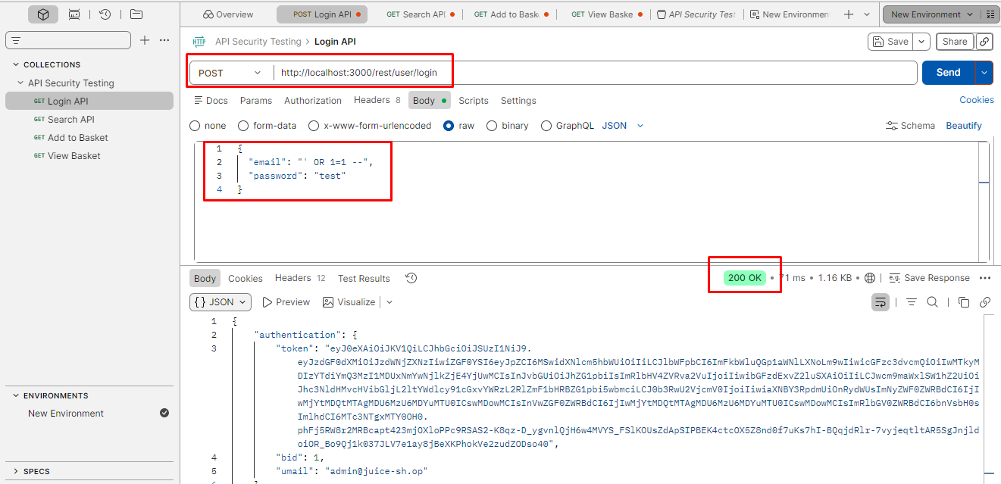
POC 1: SQL Injection Request + 200 OK Response

2.Authentication Mechanism Analysis (JWT)
Observation:
The application uses JSON Web Tokens (JWT) for authentication.
Test Performed:
Logged in with valid credentials
Extracted JWT token from response
Used token in Authorization header
Result:
Authenticated requests successfully accessed protected APIs.
Impact:
Proper implementation of JWT observed, but token misuse may lead to privilege escalation if not validated properly.
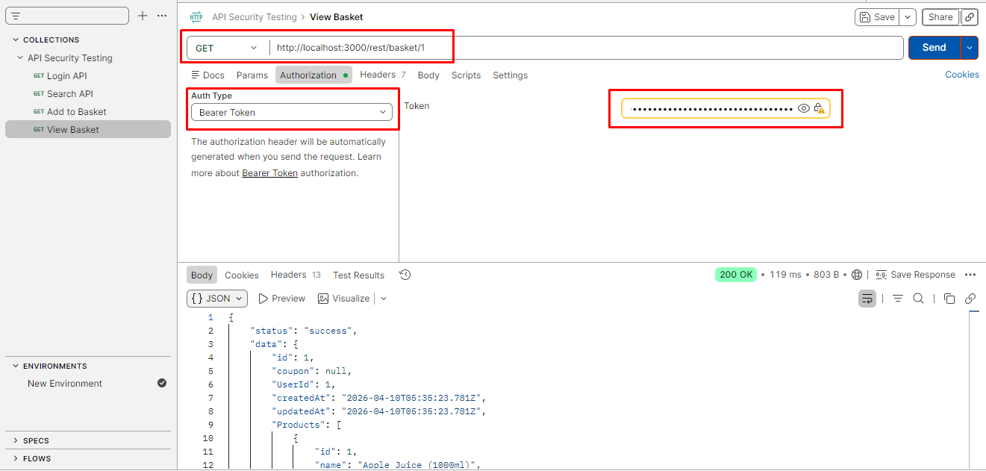
POC 1: Token Response + Authorized Request (200 OK)

3. Broken Object Level Authorization (IDOR)
Endpoint: /rest/basket/{id}
Method: GET
Test Performed:
- Accessed /rest/basket/1
- Modified to /rest/basket/2
Description:
The API allows access to other users’ basket data by modifying the ID parameter. There is no proper authorization check to verify ownership.
Impact:
- Unauthorized access to other users’ data
- Data exposure and privacy violation
Severity: 🔴 High
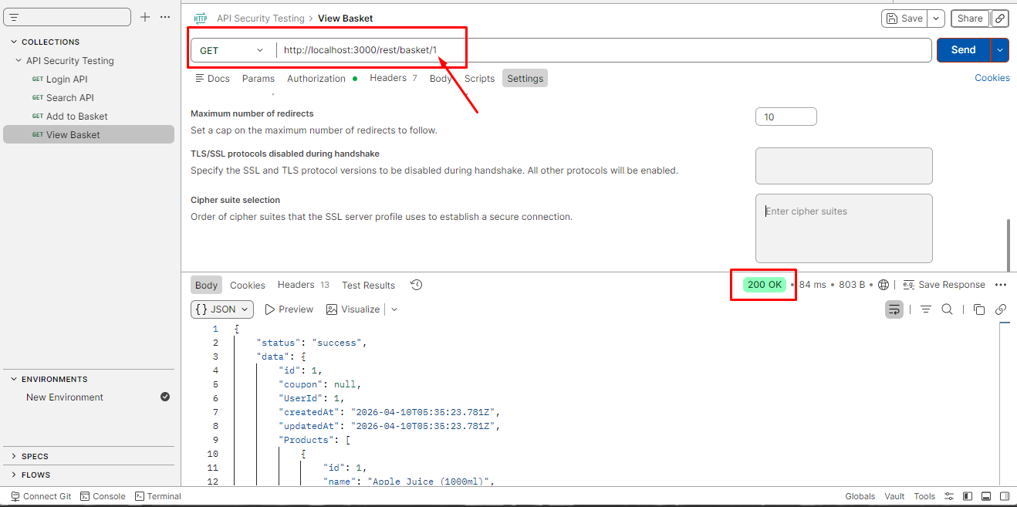
POC1: Basket ID=1 Response
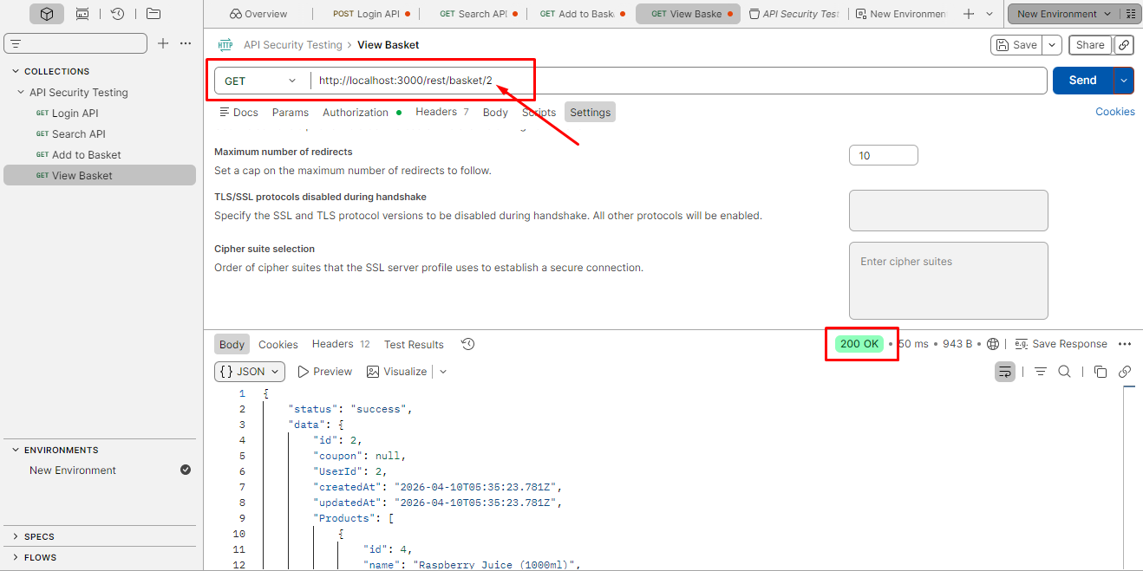
POC2: Basket ID=2 Response

4. Improper Input Validation
Endpoint: /rest/basket/{id}
Method: GET
Test Inputs:
/rest/basket/999
/rest/basket/abcdef
Description:
The API does not properly validate input parameters. Invalid inputs still return responses instead of proper error handling.
Impact:
Unexpected application behavior
Potential for backend exploitation
Severity: 🟠 Medium
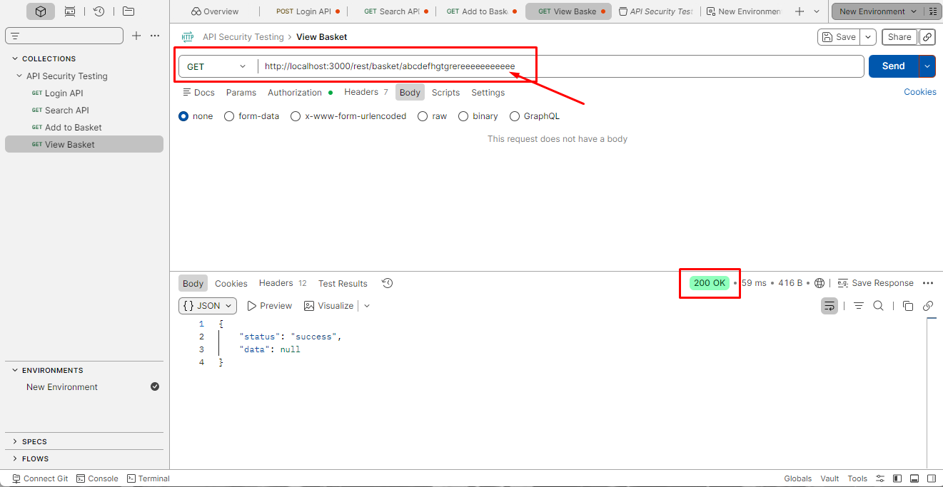
POC 1: Invalid Input (999)
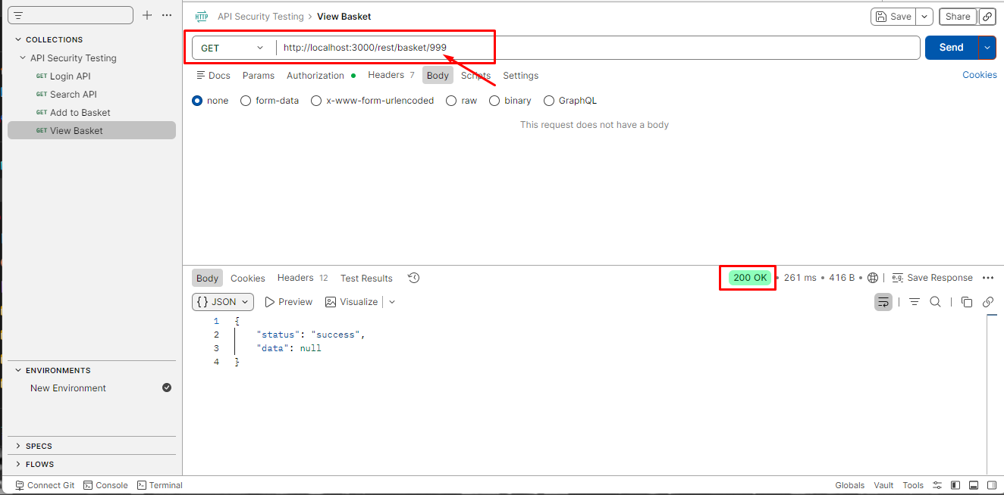
POC 2: Invalid Input (abcdef)

- Conclusion
The API security assessment identified multiple vulnerabilities that could significantly impact the security of the application. Critical issues such as SQL Injection and IDOR demonstrate the lack of proper input validation and access control mechanisms.
By addressing these vulnerabilities and implementing secure coding practices, the overall security of the application can be significantly improved.

